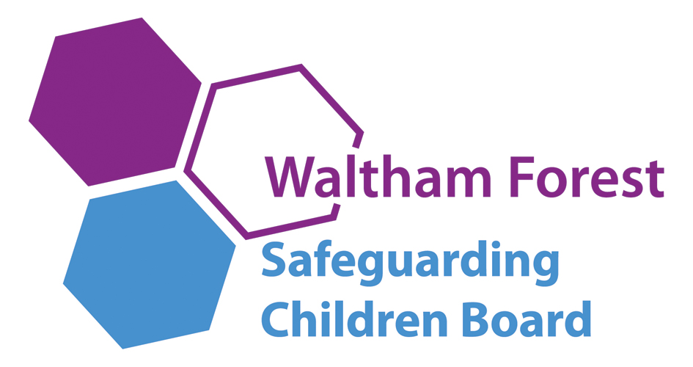


SAFEGUARDING POLICY FOR EARLY YEARS AND CHILDCARE
2016

Owner/Manager Olabisi Ogunsalu and Gabriel Ezemah

Owner Olabisi Ogunsalu and Gabriel Ezemah

Named personnel with designated responsibility for Safeguarding

Year | Designated Safeguarding Lead | Deputy Designated Safeguarding Lead | Nominated Safeguarding Owner | Chair of Governors/Committee
2016 | Olabisi Ogunsalu | Gabriel Ezemah | Olabisi Ogunsalu and  Gabriel Ezemah | N/A

Named personnel with designated responsibility regarding allegations against staff

Year | Designated Senior Manager (this would normally be the Manager/Owner) | Deputy Designated Senior Manager | Chair of Governors/Owner | Nominated Governor/committee member
2016 | Olabisi Ogunsalu | Gabriel Ezemah | Olabisi Ogunsalu and  Gabriel Ezemah | N/A

INTRODUCTION

This policy is in line with the Statutory Framework for the Early Years Foundation Stage (EYFS) (2014), Working Together to Safeguard Children (2015) and the London Child Protection Procedures (5th Edition). Keeping Child Safe in Education (2015), Working Together to Safeguard Children (2015), ‘What to do if You are Worried a Child is Being Abused’ 2015 and
WF Early Help and Threshold Criteria for Intervention

The Early Years Teacher Standards 2013 state that EY Teachers must Safeguard and promote the welfare of children, and provide a safe learning environment To do this effectively, early years teachers must implement clear policies and procedures and know and act upon the legal requirements and guidance on health and safety, safeguarding and promoting the welfare of the child.

This policy applies to all adults, including volunteers, working in or on behalf of this setting (Docklands Day Nursery)

Everyone working in or for our settings shares an objective to help keep children and young people safe by contributing to:

- Providing a safe environment for children and young people to learn and develop in our setting/childminder setting, and
- Identifying children and young people who are suffering or likely to suffer significant harm, and taking appropriate action with the aim of making sure they are kept safe both at home and in our setting/childminder setting

SETTING COMMITMENT

Docklands Day Nursery is committed to Safeguarding and Promoting the Welfare of all of its children. Every child’s welfare is of paramount importance.

We recognise that:

- Some children may be especially vulnerable to abuse
- Children who are abused or neglected may find it difficult to develop a sense of self worth and to view the world in a positive way. Whilst at setting, their behavior may be challenging
- Children can be victims and perpetrators of abuse
- Children who harm others may have been abused themselves
- Allegations can be made against staff, however careful and safe our recruitment practices

This policy will be updated annually and known to everyone working in the setting/establishment and the governing body. It will be available to parents on request.

PROVIDING A SAFE AND SUPPORTIVE ENVIRONMENT

Safer Recruitment and Selection

- The setting pays full regard to the statutory guidance for EY settings; Keeping Child Safe in Education (2015). We ensure that all appropriate measures are applied in relation to everyone who works in the setting and who is therefore likely to be perceived by the children as a safe and trustworthy adult. This includes volunteers, supervised volunteers and staff employed by contractors. Safer recruitment practice includes scrutinising applicants, verifying identity and academic or vocational qualifications, obtaining professional references, checking previous employment history and ensuring that a candidate has the health and physical capacity for the job. It also includes undertaking interviews and checks with the Disclosure and Barring Service (DBS).
Our setting endeavours to ensure that we do our utmost to employ safe staff by following the [guidance in Keeping Children Safe in Education (2015) together with the LSCB and] the setting’s Staff Recruitment policy and procedures (Copies are in the safeguarding file number 33 in the office).

Safer recruitment means that applicants will:

- complete an application form which includes their employment history and explain any gaps in that history
- provide two referees, including at least one who can comment on the applicant’s suitability to work with children
- provide evidence of identity and qualifications
- if offered employment, be checked in accordance with the Disclosure and Barring Service (DBS) regulations as appropriate to their role. This will include an enhanced DBS check and a barred list check for those engaged in Regulated Activity
- if offered employment, provide evidence of their right to work in the UK
- be interviewed, if shortlisted.

The setting will also:

- verify the preferred candidate’s mental and physical fitness to carry out their work responsibilities
- obtain references for all shortlisted candidates, including internal candidates
- carry out additional or alternative checks for applicants who have lived or worked outside the UK

At least one member of each recruitment panel will have attended safer recruitment training.

All new members of staff will undergo an induction that includes familiarisation with the setting’s child protection policy and staff behaviour policy and identification of their child protection training needs.

All staff sign to confirm they have received a copy of the child protection policy and staff behaviour policy.

All relevant staff (involved in early years settings and/or before or after school care for children under eight) are made aware of the disqualification and disqualification by association legislation and their obligations to disclose relevant information to the setting (You might want to say how awareness is raised eg. with a staff/volunteer briefing, a clause in employment contracts for new staff etc)

The setting obtains written confirmation from supply agencies or third party organisations that agency staff or other individuals who may work in the school have been appropriately checked.

The setting maintains a single central record of recruitment checks undertaken.

Regulated Activity
EY settings are ‘specified places’ which means that the majority of staff and volunteers will be engaged in regulated activity. A fuller explanation of regulated activity can be found in Keeping Children Safe in Education (2015) part three.

Volunteers
Volunteers, including trustees will undergo checks commensurate with their work in the setting and contact with children attending the setting. Under no circumstances will a volunteer who has not been appropriately checked be left unsupervised or be allowed to engage in regulated activity.

Supervised volunteers
Volunteers who work only in a supervised capacity and are not in regulated activity will undergo the safe recruitment checks appropriate to their role, in accordance with the setting’s risk assessment process and statutory guidance.

Contractors
The setting checks the identity of all contractors working on site and requests DBS checks and barred list checks where required by statutory guidance. Contractors who have not undergone checks will not be allowed to work unsupervised or engage in regulated activity.

This setting is committed to keeping an up to date single central record detailing a range of checks carried out on our staff

(Olabisi Ogunsalu and Gabriel Ezemah)

Safe Practice

Our setting will comply with the current Guidance for Safer Working Practice for Adults who work with Children and Young People and ensure that information in this guidance regarding conduct, is known to all staff, visitors and volunteers who come into the school.

Safe working practice ensures that children are safe and that all staff:
- are responsible for their own actions and behaviour and should avoid any conduct which would lead any reasonable person to question their motivation and intentions;
- work in an open and transparent way;
- work with other colleagues where possible in situations that could be open to question
- discuss and/or take advice from school management over any incident which may give rise for concern;
- record any incidents or decisions made;
- apply the same professional standards regardless of diversity issues;
- be aware of information-sharing and confidentiality policies;
- are aware that breaches of the law and other professional guidelines could result in criminal or disciplinary action being taken against them.

Helping children to keep themselves safe

Children are taught to understand safety and manage risk through embedding the prime areas of personal, social, and emotional development and communication in all aspects of our care. Our approach is designed to help children to think about safety and with the support of staff work out how to keep themselves safe. Discussions about safety are empowering and enabling for all children and promote sensible behaviour rather than fear or anxiety. Children are taught how to conduct themselves and how to behave in a responsible manner, as well as develop a language to share concerns. Children are also reminded regularly of how to keep themselves safe from relevant risks such as abuse and extremism, including when using the internet and social media

Through curriculum opportunities, children are helped to talk about their feelings to deal with assertively with pressures and know whom they can turn to for advice and help.

All children know that we have a designated safeguarding lead with responsibility for safeguarding and know who this is.

We inform children of whom they might talk to, both in and out of setting/establishment, their right to be listened to and heard and what steps can be taken to protect them from harm.

Partnership with Parents

The setting/establishment shares a purpose with parents to educate and keep children safe from harm and to have their welfare promoted. We are committed to working with parents positively, openly and honestly. We ensure that all parents are treated with respect, dignity and courtesy. We respect parents’ rights to privacy and confidentiality and will not share sensitive information unless we have permission or it is necessary to do so in order to protect a child.

The setting/establishment will, in most circumstances, endeavour to discuss all concerns with parents about their children. However, there may be exceptional circumstances when the setting/establishment will discuss concerns with Social Care and/or the Police without parental knowledge (in accordance with the London Child Protection procedures). The setting/establishment will, of course, always aim to maintain a positive relationship with all parents. The setting/establishment child protection policy is available on request.

Partnerships with others

Our setting/establishment recognises that it is essential to establish positive and effective working relationships with other agencies that are partners of the Waltham Forest Safeguarding Children Board. There is a joint responsibility on all these agencies to share information to ensure the safeguarding of all children.

Setting Training and Staff Induction

The setting’s/establishment’s designated safeguarding lead and or governor/committee member with designated responsibility for safeguarding will undertake child protection training for designated safeguarding leads and refresher training at yearly intervals.

All other settings staff, including voluntary staff, will undertake appropriate induction training or safeguarding/child protection training to enable them to carry out their responsibilities for safeguarding effectively, which is kept up to date by refreshing training at two yearly intervals.

All staff (including temporary staff volunteers, supervised volunteers and staff employed by contractors) are provided with the setting’s/establishment’s safeguarding policy and informed of the setting’s/establishment’s safeguarding arrangements on induction.

Support, Advice and Guidance for Staff

Staff will be supported by (Gabriel Ezemah and Olabisi Ogunsalu ). The DSL will be supported by Waltham Forest Local Authority Designated Officer (LADO) 020 8496 3646).

The DSL will know how to access the on-line London Child Protection Procedures.
If you are not sure whether or not to make a referral to Children’s Social Care, you can contact the Waltham Forest Multi Agency Safeguarding Hub (MASH) Team/Children’s Referral and Advice Team based at Juniper House.

See Appendix 2 – Key Contacts for Child Protection Issues in Waltham Forest

Supervision of Staff

Developing effective staff supervision in early year’s settings is crucial in ensuring safe practice and staff training needs. The LA has produced a supervision toolkit with a supervision template for EY practitioners to use.

Staff in settings will require regular supervision by a trained supervisor. Each setting needs to develop a supervision policy to include a supervision contract between staff and supervisor.

The setting will continue to be supported by the development workers who provide regular advice and support. They are expected, however, to carry out effective staff supervision

Related Setting/Establishment Policies

Safeguarding covers more than the contribution made to child protection in relation to individual children. It also encompasses issues such as health and safety, bullying and a range of other issues, for example, arrangements for meeting the medical needs of children providing first aid, setting/establishment security including the use of cameras and mobile phones, drugs and substance misuse, positive behaviour etc. There may also be other safeguarding issues that are specific to the local area or population.

Bullying

While bullying between children is not a separate category of abuse and neglect, it is a very serious issue that can cause considerable anxiety and distress. At its most serious level, can have a disastrous effect on a child’s wellbeing and in very rare cases has been a feature in the suicide of some young people.

All incidences of bullying should be reported and will be managed through our anti-bullying procedures. The subject of bullying is addressed at regular intervals in the personal, social and communication (EYFS) curriculum.

E-Safety

The setting/establishment recognises that children will use mobile phones and computers at some time. They are a source of fun, entertainment, communication and education. Young children increasingly use electronic equipment on a daily basis to access the internet and share content and images via social networking sites. However, we know that some men, women and young people will use these technologies to harm children. The harm might range from sending hurtful or abusive texts and emails, to enticing children to engage in sexually harmful conversations, web cam photography or face-to-face meetings. Children may also be distressed or harmed by accessing inappropriate websites that promote unhealthy lifestyles, extremist behaviour and criminal activity.

The setting has an e-safety policy that is known to all staff and children.

The setting’s e-safety policy (Policy and procedure folder no 28) explains how we try to keep children safe at the setting and protect and educate children in the safe use of technology.

Many children either own or have access to hand held devices and parents are encouraged to consider measures to keep their children safe when using the internet and social media at home and in the community.

Photography and Images

The vast majority of people who take or view photographs or videos of children do so for entirely innocent, understandable and acceptable reasons. Sadly, some people abuse children through taking or using images, so we must ensure that we have some safeguards in place.

To protect children we will:
- Seek parental consent
- Use only the child’s first name with an image
- Ensure children are appropriately dressed
- Encourage child to tell us if they are worried about any photographs that are taken of them
- Have a policy regarding staff use of mobile phones within the workplace

Children Missing from Setting/establishment

Attendance, absence and exclusions are closely monitored. A child with an unexplained absence from the setting may be a potential indicator of abuse and neglect. The DSL will monitor unexplained/unauthorised absence and take appropriate action including notifying the local authority, particularly where children go missing on repeated occasions and/or are missing for periods during the school day. Staff must be alert to signs of children at risk of travelling to conflict zones, female genital mutilation and forced marriage.

After school/Holiday Schemes, Breakfast club providers

Where after school clubs, holiday schemes, breakfast clubs are used in EY settings, these schemes must ensure they have their own safeguarding policy and procedures. If other organisations provide services or activities on your site, you must check that they have appropriate procedures in place, including safer recruitment procedures.

Confidentiality

The setting will operate with regard to Information Sharing: Guidance for practitioners and managers (2015), and have a clear and explicit confidentiality policy.

“Where there is a concern that the child may be suffering or is at risk of suffering significant harm, the child’s safety and welfare must be the overriding consideration.“

The setting’s policy should indicate:

- When information must be shared with police and social care where the child/young person is / may be at risk of significant harm
- When the pupil’s and/or parent’s confidentiality must not be breached
- That information is shared on a need to know basis

Child Information

The setting/establishments record-keeping policy for child welfare and child protection is consistent with the EYFS guidance, which is known to all staff.

In order to keep children safe and provide appropriate care for them, our setting/establishment requires accurate and up to date information regarding:

- names and contact details of persons with whom the child normally lives
- names and contact details of all persons with parental responsibility (if different from above)
- emergency contact details (if different from above)
- details of any persons authorised to collect the child from setting (if different from above)
- any relevant court orders in place including those, which affect any person’s access to the child (e.g. Residence Order, Contact Order, Care Order, Injunctions etc.)
- if the child is or has been subject to a child protection or care plan
- name and contact detail of G.P.
- any other factors which may impact on the safety and welfare of the child

The setting/establishment will collate, store and agree access to this information.

All child protection documents will be retained in a ‘Child Protection’ file, separate from the child’s main file. The main file will clearly show an alert that a child protection file exists and the location of this. This child protection file will be locked away and only accessible to the Owner/manager and senior designated person. These records will be copied and transferred to any setting or setting the child moves to, clearly marked ‘Child Protection, Confidential, for attention of Designated Person Child Protection. Original copies will be retained according to setting/establishment policy on retention of records.

Roles and Responsibilities

Our Governing Body/Committee/Owner will ensure that:
- the setting/establishment has a safeguarding policy and procedures in place that are in accordance with local authority guidance and locally agreed inter-agency procedures, and the policy is made available to parents on request;
- the setting/establishment operates safer recruitment procedures and makes sure that all appropriate checks are carried out on staff and volunteers who work with children;
- the setting/establishment follows the London Child Protection procedures for dealing with allegations of abuse against staff and volunteers
- a senior member of the setting/establishment leadership team is designated to take lead responsibility for safeguarding (and deputy);
- they have a named owner/committee lead for safeguarding;
- staff undertake appropriate safeguarding/child protection training, at regular intervals;
- they remedy, without delay, any deficiencies or weaknesses regarding safeguarding arrangements;
- a committee member (where relevant) is nominated to be responsible for liaising with the LA and /or partner agencies in the event of allegations of abuse being made against the owner/manager ;
- where services or activities are provided on the setting/childminder premises by another body, the body concerned has appropriate policies and procedures in place in regard to safeguarding children and liaises with the setting/childminder on these matters where appropriate;
- they review their policies and procedures annually and provide information to the LA about them and about how the above duties have been discharged

Our Owner/Manager will ensure that:
- The policies and procedures adopted by the Governing Body/Committee or Proprietor are fully implemented, and followed by all staff;
- Sufficient resources and time are allocated to enable the designated person and other staff to discharge their responsibilities; and
- All staff and volunteers feel able to raise concerns about poor or unsafe practice in regard to children, and such concerns are addressed sensitively and effectively in a timely manner in accordance with the agreed Whistle Blowing Policy (Appendix 3);
- They have completed Safer Recruitment training;
- The procedure for managing allegations against staff is known to staff and displayed in staff rooms;
- Operate the procedure for managing allegations effectively and refer relevant concerns to the Local Authority Designated Officer (LADO);
- Appoint a deputy senior manager to deal with allegations against staff in the absence of the owner/manager

Senior Member of Staff with Designated Responsibility for Child Protection will:

Referrals
- Refer cases of suspected abuse or allegations to children’s social care and maintain a record of all referrals;
- Act as a source of support, advice and expertise within the educational establishment and have access to the online London Child Protection Procedures;
- Liaise with the owner/manager to inform him/her of any issues and ongoing investigations and ensure there is always cover for this role.

Training
- Recognise how to identify signs of abuse and know when it is appropriate to make a referral;
- Have knowledge of the escalation policy, the Local Authority Designated Officer (LADO) role, conduct of a child protection case conference and be able to attend and contribute to these;
- Ensure that all staff have access to and understand the setting/establishment’s safeguarding policy;
- Ensure that all staff have induction training;
- Keep detailed, accurate and secure written records;
- Obtain access to resources and attend any relevant or refresher training courses at least every two years.

Raising Awareness
- Ensure the safeguarding policy is updated and reviewed annually and work with the Governing Body/Committee or Proprietor regarding this;
- Ensure parents are made aware of the safeguarding policy which alerts them to the fact that referrals may be made and the role of the establishment in this to avoid conflict later;
- Where a child leaves the establishment, ensure the child protection file is copied for the new establishment ASAP and transferred to the new setting/childminder separately from the main pupil file.

All staff and volunteers will:

Fully comply with the setting/childminder’s policies and procedures, attend appropriate training and inform the designated lead of any concerns.

IDENTIFYING CHILDREN AND YOUNG PEOPLE WHO MAY BE SUFFERING SIGNIFICANT HARM

Staff in settings/childminders are well placed to observe any physical, emotional or behavioural signs, which indicate that a child may be suffering significant harm. The relationships between staff, children, parents and the public which foster respect, confidence and trust can lead to disclosures of abuse, and/or settings/childminders being alerted to concerns.

As in the Children Acts 1989 and 2004, a child is anyone who has not yet reached his/her 18th birthday.

Harm means ill-treatment or impairment of health and development, including, for example, impairment suffered from seeing or hearing the ill-treatment of another; Development means physical, intellectual, emotional, social or behavioural development; Health includes physical and mental health; Ill-treatment includes sexual abuse and other forms of ill-treatment which are not physical.

Abuse and Neglect are forms of maltreatment. Somebody may abuse or neglect a child by inflicting harm or failing to act to prevent harm. Children may be abused in a family or in an institutional or community setting, by those known to them, or, more rarely, by a stranger. They may be abused by an adult or adults, another child, children or young people. There are four categories of abuse; physical abuse, emotional abuse, sexual abuse and neglect.

Child protection procedures

Recognising abuse
To ensure that our children are protected from harm, we need to understand what types of behaviour constitute abuse and neglect.

Abuse and neglect are forms of maltreatment. Somebody may abuse or neglect a child by inflicting harm, for example by hitting them, or by failing to act to prevent harm, for example by leaving a small child home alone, or leaving knives or matches within reach of an unattended toddler.

Abuse may be committed by adult men or women and by other children and young people.

Four categories of abuse:

Physical Abuse
Physical abuse is a form of abuse which may involve hitting, shaking, throwing, poisoning, burning or scalding, drowning, suffocating or otherwise causing physical harm to a child. Physical harm may also be caused when a parent or carer fabricates the symptoms of, or deliberately induces, illness in a child. (This used to be called Munchausen’s Syndrome by Proxy, but is now more usually referred to as fabricated or induced illness).

Emotional Abuse
Emotional abuse is the persistent emotional maltreatment of a child such as to cause severe and persistent adverse effects on the child’s emotional development. It may involve conveying to a child that they are worthless or unloved, inadequate, or valued only insofar as they meet the needs of another person. It may include not giving the child opportunities to express their views, deliberately silencing them or ‘making fun’ of what they say or how they communicate. It may feature age or developmentally inappropriate expectations being imposed on children. These may include interactions that are beyond a child’s developmental capability, as well as overprotection and limitation of exploration and learning, or preventing the child participating in normal social interaction. It may involve seeing or hearing the ill-treatment of another. It may involve serious bullying (including cyber bullying), causing children frequently to feel frightened or in danger, or the exploitation or corruption of children. Some level of emotional abuse is involved in all types of maltreatment of a child, although it may occur alone.

Sexual Abuse
Sexual abuse involves forcing or enticing a child or young person to take part in sexual activities, not necessarily involving a high level of violence, whether or not the child is aware of what is happening. The activities may involve physical contact, including assault by penetration (for example, rape or oral sex) or non-penetrative acts such as masturbation, kissing, rubbing and touching outside of clothing. They may also include non-contact activities, such as involving children in looking at, or in the production of, sexual images, watching sexual activities, encouraging children to behave in sexually inappropriate ways, or grooming a child in preparation for abuse (including via the internet). Sexual abuse is not solely perpetrated by adult males. Women can also commit acts of sexual abuse, as can other children.

Neglect
Neglect is the persistent failure to meet a child’s basic physical and/or psychological needs, likely to result in the serious impairment of the child’s health or development. Neglect may occur during pregnancy as a result of maternal substance abuse. Once a child is born, neglect may involve a parent or carer failing to:
- provide adequate food, clothing and shelter (including exclusion from home or abandonment);
- protect a child from physical and emotional harm or danger;
- ensure adequate supervision (including the use of inadequate care-givers); or
- ensure access to appropriate medical care or treatment. It may also include neglect of, or unresponsiveness to, a child’s basic emotional needs.

Definitions taken from Keeping Children Safe in Education 2015.

Children who may be particularly vulnerable
Some children may have an increased risk of abuse. It is important to understand that this increase in risk is due more to societal attitudes and assumptions or child protection procedures that fail to acknowledge children’s diverse circumstances, rather than the individual child’s personality, impairment or circumstances. Many factors can contribute to an increase in risk, including prejudice and discrimination, isolation, social exclusion, communication issues and a reluctance on the part of some adults to accept that abuse can occur.

To ensure that all of our children receive equal protection, we will give special consideration to children who are:

- disabled or have special educational needs
- young carers
- affected by parental substance misuse, domestic violence or parental mental heath needs
- asylum seekers
- living away from home
- vulnerable to being bullied, or engaging in bullying
- living in temporary accommodation
- live transient lifestyles
- living in chaotic and unsupportive home situations
- vulnerable to discrimination and maltreatment on the grounds of race, ethnicity, religion, disability or sexuality
- at risk of sexual exploitation
- do not have English as a first language
- at risk of female genital mutilation (FGM)
- at risk of forced marriage
- at risk of being drawn into extremism.

This list provides examples of additionally vulnerable groups and is not exhaustive. Special consideration includes the provision of safeguarding information and resources in community languages and accessible formats for children with communication needs.

Female Genital Mutilation (FGM)

FGM is illegal in the UK and a form of child abuse with long-lasting harmful consequences. Professionals in all agencies, and individuals and groups in relevant communities, need to be alert to the possibility of a girl being at risk of FGM, or already having suffered FGM.

FGM refers to procedures of any alteration involving partial or total removal of the external female genital organs. The procedure may lead to short term and long-lasting harmful consequences such as death, trauma, infections, flashbacks, infertility, kidney problems, sexual dysfunctions, incontinence, post-traumatic stress disorder etc. It is known to be practised in the North African countries, the Middle-East, Indonesia, Malaysia, India and Pakistan. However, with migration worldwide it is also practised in the UK, the USA, Canada, Australia etc.

One of the prominent reasons for the practice is to suppress women’s sexual desire. There is a social pressure on women to undergo the procedure otherwise they may be segregated by their peers, or labelled “unclean”. Furthermore, FGM is often a requirement for getting married in practicing communities. FGM is not a religious practice.

Indicators

There is a range of potential indicators that a girl may be at risk of FGM.

FGM often takes place in the summer holidays, as the recovery period after FGM can be 6 to 9 weeks. Professionals should be mindful of at risk times when children go on long holidays and/or are getting a visit by female elder from their country of origin. Additionally, girls are considered at risk where their mother or sisters have undergone FGM, and girls are talking about a ‘special’ event or procedure to ‘become a woman.’

The post FGM symptoms include, but are not limited to, difficulty in walking, sitting or standing, spending longer than normal in the bathroom or toilet, unusual behaviour after a lengthy absence, reluctance to undergo normal medical examinations, and asking for help but not be explicit about the problem due to embarrassment or fear. They can sometimes ask about their friend’s problem rather than their problem. Professionals should raise an alert to child social care via the MASH if they have any FGM concerns.

Further information on warning signs that FGM may be about to take place, or may have already taken place, can be found on pages 16-17 of the Multi-Agency Practice Guidelines.

Actions

The United Nations addresses FGM as violation of human rights. In the UK, FGM is a criminal offence and a harmful form of child abuse. It is illegal to practice in the UK and/or anyone involved in taking girl outside of the UK to have FGM carried out will be punished under the FGM Act 2003 and Serious Crime Act 2015. LBWF follows a comprehensive approach comprising prevention, punishment, enforcement, support and protection measures to safeguard young girls from FGM.

Mandatory Reporting Duty

Section 5C of the Female Genital Mutilation Act 2003 (as inserted by section 75 of the Serious Crime Act 2015) gave the Government powers to issue statutory guidance on FGM to relevant persons. The draft statutory guidance draws on the existing FGM multi-agency practice guidelines and has been updated to capture legal changes resulting from provisions in the Serious Crime Act 2015, new guidance for health professionals, new sources of data on FGM and wider safeguarding responsibilities, duties and resources for professionals. It also includes guidance on the new mandatory reporting, which came into effect on 31st October 2015.

The guidance provides professionals with the information they need to help them understand the issues around FGM; professionals’ responsibilities on FGM linked to wider safeguarding duties and good practice; the range of legal interventions to deal with FGM; guidelines for key professionals including police, healthcare professionals, children’s social care and schools and colleges, and working with communities to prevent FGM.

Section 5B of the Female Genital Mutilation Act 2003 (as inserted by section 74 of the Serious Crime Act 2015)l places a statutory duty upon teachers, along with social workers and healthcare professionals, to report to the police where they discover (either through disclosure by the victim or visual evidence) that FGM appears to have been carried out on a girl under 18. Those failing to report such cases will face disciplinary sanctions. It will be rare for teachers to see visual evidence, and they should not be examining children – it is likely that discovery will be made by disclosure by the student, parent or otherwise. These cases must be referred to police (via the local CAIT team or by calling 101). Immediate reporting is required if FGM has been performed recently, and in historical cases, reporting must take place within one month.

Unless the teacher has a good reason not to, they should still consider and discuss any such case with the school’s designated safeguarding lead and involve children’s social care as appropriate. While the duty is limited to the specified professionals described above, non-regulated practitioners also have a responsibility to take appropriate safeguarding action in relation to any identified or suspected case of FGM, in line with wider safeguarding frameworks. If staff have a concern they should activate local safeguarding procedures via the MASH, using existing national and local protocols for multi-agency liaison with police and children’s social care.

Settings can also:

- Circulate and display materials about FGM
- Display relevant information (for example, details of the NSPCC’s Helpline and appropriate black and minority ethnic women’s groups)
- Inform colleagues/raise awareness of the issues around FGM – as well as including appropriate training in continuing professional development

Reference and further information

- Keeping children safe in education, DfE (see pages 14-15)
- Multi-agency practice guidelines: FGM, Home Office, DfE (see pages 8, 16, 17 and 42
- http://www.londonscb.gov.uk/fgm/

Free online training from the Home Office

https://www.fgmelearning.co.uk/

For support around training around FGM for teachers and students, please contact:
Hibo Wardere
FGM Mediator

Tel: 020 8496 6952
Hibo.Wardere@walthamforest.gov.uk

PREVENT

We are fully aware and committed to the on-going protection and safety of our children, staff and wider community in accordance with DfE guidance ‘Working together to Safeguard Children’ (2015) and ‘Keeping Children Safe in Education’ (2015). An integral part of that work relates to the governments PREVENT strategy and the duties it places on education settings..
We are committed to providing a secure environment, where children feel safe and are kept safe. All adults in our setting recognise that safeguarding is everyone’s responsibility irrespective of the role they undertake or whether their role has direct contact or responsibility for children or not. Staff will be alert to issues including:
- Disclosures by children of their exposure to the extremist actions, views or materials of others outside of the setting, such as in their homes or community groups
- Graffiti symbols, writing or art work promoting extremist messages or images
- Children accessing extremist material online, including through social networking sites
- Parental reports of changes in behaviour, friendship or actions and requests for assistance
- Use of extremist or ‘hate’ terms to exclude others or incite violence
- Intolerance of difference, whether secular or religious or, in line with our equalities policy, views based on, but not exclusive to, gender, disability, homophobia, race, colour or culture
By continually developing our leadership and accountability practices, staff training opportunities referral systems and management of those referrals, we strive to demonstrate a pro-active and diligent approach to this aspect of our responsibilities as educators and safe-guarders.

Aligned with a consistent delivery of a broad and balanced curriculum which promotes British Values through the EYFS, we strive to protect our students - and the wider community - against the threats of extremism, through the promotion of both fundamental values and cohesion amongst our communities.

We also recognise that further information and support is available from the Multi-Agency Safeguarding Hub (0208 496 2310) and the Local Authority’s Community Safety Team (0208 496 3000).

What is Child Abuse linked to faith and belief?

There is no agreed definition of or consensus about the concept of 'child abuse linked to faith or belief'. Child abuse linked to faith or belief can be separated into four areas as follows;
- Abuse that occurs as a result of a child being accused of witchcraft or of being a witch
- Abuse that occurs as a result of a child being accused of being 'possessed by spirits' that is, 'spirit possession'
- Ritualistic abuse
- Satanic abuse
The forms the abuse can take include;
- Physical abuse: beating, burning, cutting, stabbing, semi-strangulating, tying up the child, or rubbing chilli peppers or other substances on the child's genitals or eyes
- Emotional abuse: in the form of isolation {e.g. not allowing a child to ear or share a room with family members or threatening to abandon them}. The child may also be persuaded that they are possessed
- Neglect: failure to ensure appropriate medical care, supervision, school attendance, good hygiene, nourishment, clothing or warmth
- Sexual abuse; within the family or community, children abused in this way may be particularly vulnerable to sexual exploitation

Where does it take place?
Child Abuse linked to faith and/or belief is not confined to one faith, nationality or ethnic community. Examples have been recorded worldwide among Europeans, Africans, Asians and elsewhere as well as in Christian, Muslim, Hindu and pagan faiths among others.
Not all those who believe in witchcraft or spirit possession harm children. Data on numbers of known cases suggests that only a small minority of people with such beliefs go on to abuse children.

Common factors that put a child at risk of harm include;
- Belief in evil spirits: this is commonly accompanied by a belief that the child could 'infect' others with such 'evil'. The explanation for how a child becomes possessed varies widely, but includes through food that they have been given or through spirits that have flown around them;
- Scapegoating because of a difference: it may be that the child is being looked after by adults who are not their parents (i.e. privately fostered), and who do not have the same affection for the child as their own children;
- Rationalising misfortune by attributing it to spiritual forces and when a carer views a child as being 'different' because of disobedience, rebelliousness, over-independence, bedwetting, nightmares, illness or because they have a perceived or physical abnormality or a disability; Disabilities involved in documented cases included learning disabilities, mental ill health, epilepsy, autism, a stammer and deafness;
- Changes and / or complexity in family structure or dynamics: there is research evidence (see Stobart, Child Abuse linked to Accusations of Spirit Possession - see related links] that children become more vulnerable to accusations of spirit possession following a change in family structure (e.g. a parent or carer having a new partner or transient or several partners). The family structure also tended to be complex so that exact relationships to the child were not immediately apparent. This may mean the child is living with extended family or in a private fostering arrangement (see Children Living Away from Home Procedure, Private Fostering - see related link). In some cases, this may even take on a form of servitude;
- Change of family circumstances for the worse: a spiritual explanation is sought in order to rationalise misfortune and the child is identified as the source of the problem because they have become possessed by evil spirits. Research evidence is that the family's disillusionment very often had its roots in negative experiences of migration:
in the vast majority of identified cases in the UK to date, the families were first or second generation migrants suffering from isolation from extended family, a sense of not belonging or feeling threatened or misunderstood. These families can also have significantly unfulfilled expectations of quality of life in the UK;
- Parental difficulties: a parent's mental ill health appears to be attributed to a child being possessed in a significant minority of cases. Illnesses typically involved include post-traumatic stress disorder, depression and schizophrenia.
The Law in relation to child abuse linked to faith and belief
There are sufficient existing laws within the UK with which to prosecute those responsible for child abuse linked to faith and/or belief thereby negating any need for further more specific offences.

What to do if you suspect a child is at risk from abuse linked to faith and/or belief
Concerns about a child’s welfare can vary greatly in terms of their nature and seriousness. If you have concerns about a child, you should ask for help. You should discuss your concerns with your manager, a named or designated professional or a designated member of staff.
For example;
- for school staff (both teaching and non-teaching) concerns should be reported via the school’s or college’s designated safeguarding lead. The safeguarding lead will usually decide whether to make a referral to children’s social care;
- for early years practitioners, the Early Years Foundation Stage sets out that providers should ensure that they have a practitioner who is designated to take a lead responsibility for safeguarding children who should liaise with local statutory children’s services agencies.

Private fostering arrangements
A private fostering arrangement occurs when someone other than a parent or a close relative cares for a child for a period of 28 days or more, with the agreement of the child’s parents. It applies to children under the age of 16, or aged under 18 if the child is disabled. Children looked after by the local authority or who are placed in a residential school, children’s home or hospital are not considered to be privately fostered.
Private fostering occurs in all cultures, including British culture and children may be privately fostered at any age.
Most privately fostered children remain safe and well but safeguarding concerns have been raised in some cases so it is important that schools are alert to possible safeguarding issues, including the possibility that a child has been trafficked into the country.
By law, a parent, private foster carer or other persons involved in making a private fostering arrangement must notify children’s services as soon as possible.
Where a member of staff becomes aware that a child may be in a private fostering arrangement they will raise this with the DSL and the setting should notify the local authority of the circumstances.

Domestic Abuse

Domestic abuse is any type of controlling, bullying, threatening or violent behaviour between people in a relationship. But it isn’t just physical violence – domestic abuse includes any emotional, physical, sexual, financial or psychological abuse. It can happen in any relationship, and even after the relationship has ended. Both men and women can be abused or abusers.

Witnessing domestic abuse is really distressing and scary for a child, and causes serious harm. Children living in a home where domestic abuse is happening are at risk of other types of abuse too. Children can experience domestic abuse or violence in lots of different ways. They might:
- see the abuse
- hear it from another room
- see a parent's injuries or distress afterwards
- be hurt by being nearby or trying to stop the abuse.

Domestic abuse can happen in any relationship, and it affects young people too. They may not realise that what's happening is abuse. Even if they do, they might not tell anyone about it because they're scared of what will happen, or ashamed about what people will think.

TAKING ACTION TO ENSURE THAT CHILDREN ARE SAFE
AT THE SETTING AND AT HOME

All staff should follow the DfE guidance Statutory Framework for the Early Years Foundation Stage (2014) – Section 3: The Safeguarding and Welfare Requirements

It is not the responsibility of the setting/establishment staff to investigate welfare concerns or determine the truth of any disclosure or allegation. All staff, however, have a duty to recognise concerns and maintain an open mind. Accordingly all concerns regarding the welfare of child will be recorded and discussed with the designated senior person/manager/owner with responsibility for safeguarding (or another senior member of staff in the absence of the designated person) prior to any discussion with parents.

Staff must immediately report:

- Any suspicion that a child is injured, marked, or bruised in a way which is not readily attributable to the normal knocks or scrapes received in play
- Any explanation given which appears inconsistent or suspicious
- Any behaviours which give rise to suspicions that a child may have suffered harm
- Any concerns that a child may be suffering from inadequate care, ill treatment, or emotional maltreatment
- Any concerns that a child is presenting signs or symptoms of abuse or neglect
- Any significant changes in a child’s presentation, including non-attendance
- Any suspicion, allegation disclosure of abuse about or by a child / young person
- Any concerns regarding person(s) who may pose a risk to children (e.g. living in a household with children present)
- Information which indicates that the child is living with someone who does not have parental responsibility for them (private fostering)

If you are concerned about a pupil’s welfare
There will be occasions when practitioners may suspect that a pupil may be at risk, but have no ‘real’ evidence. The pupil’s behaviour may have changed, or physical but inconclusive signs may have been noticed. In these circumstances, practitioners will try to give the child the opportunity to talk. The signs they have noticed may be due to a variety of factors, for example, a parent has moved out, a pet has died, a grandparent is very ill or an accident has occurred. It is fine for practitioners to ask the child if they are OK or if they can help in any way.

Practitioners should use the welfare concern form to record these early concerns. If the child does begin to reveal that they are being harmed, practitioners should follow the advice below. Following an initial conversation with the child, if the member of staff remains concerned, they should discuss their concerns with the DSL.

Concerns which do not meet the threshold for child protection intervention will be managed through the Early Help process.

Responding to Disclosure and Allegations

Allegations or information may be received from child, parents or other members of the public. The setting recognises that those who disclose such information may do so with difficulty, having chosen carefully to whom they will speak. Accordingly all staff will handle allegations with sensitivity. Such information cannot remain confidential and staff will immediately communicate what they have been told to the designated person and make a contemporaneous record.

Principles

Staff will not investigate but will, wherever possible, listen, record and pass on information to the designated person in order that s/he can make an informed decision of what to do next.

Staff will:
- Listen to and take seriously any information shared that a child may be at risk of harm
- Clarify the information
- Make a written record of what the child has said using the Record Form (Appendix 4)
- Try to keep questions to a minimum and of an ‘open’ nature e.g. ‘Can you tell me what happened?’ rather than ‘Did x hit you?’
- Try not to show signs of shock, horror or surprise
- Not express feelings or judgements regarding any person alleged to have harmed the child
- Explain sensitively to the person that they have a responsibility to refer the information to the senior designated person
- Reassure and support the person as far as possible
- Explain that only those who ‘need to know’ will be told
- Explain what will happen next and that the person will be involved as appropriate

Action by the Designated Safeguarding Lead/Manager/Owner (or the Deputy Designated Safeguarding Lead in their absence)

Key points for staff to remember for taking action are:

- in an emergency take the action necessary to help the child, if necessary call 999
- report your concern as soon as possible to the DSL, definitely by the end of the day
- do not start your own investigation
- share information on a need-to-know basis only – do not discuss the issue with colleagues, friends or family
- complete a record of concern
- seek support for yourself if you are distressed.

In June 2015 the local authority launched a Single Request for Help, Support and Protection, an integral part of this development was a single referral point into Children’s Social Care and Early Help within MASH. This process helps to ensure that there is:

- Timeliness of screening decisions
- Consistency of threshold decisions
- Outcomes from the single request
- Responses to referrers
- Timeliness of allocations following screening decisions

Following any information raising concern, the senior designated person will:

- Consider the child‘s wishes and feelings, but not promise confidentiality
- Consider any urgent medical needs of the child and consider contact with emergency services
- Make an immediate Request for Help, Support and Protection to Waltham Forest MASH Team if there has been a disclosure an/or allegation of abuse or there are clear grounds for concerns about the child’s safety and well-being
- Use the Ofsted online notification system if the harm happened at the setting no later than 14 days after the allegation
- Review Action when a child has suffered or is likely to suffer harm (Appendix 5) and Early help and threshold criteria for intervention
- Consult with a member of Waltham Forest MASH Team at Juniper House if they are uncertain whether or not a referral is required

In consultation with Waltham Forest MASH Team at Juniper House, decide:

- Wherever possible, to talk to parents, unless to do so may place a child at risk of significant harm, impede any police investigation and/or place the member of staff or others at risk
- Whether to make a child protection referral to social care because a child is suffering or is likely to suffer significant harm and if this needs to be undertaken immediately
- Contact the designated officer for safeguarding in another agency if that agency is working with the family
OR
- Not to make a referral at this stage, but retain the information in written notes on the child’s file
- If further monitoring is necessary and agree who and how this will be undertaken
- If it would be appropriate to undertake an Early Help Assessment and/or make a referral for other services

All information and actions taken, including the reasons for any decisions made, will be fully documented. All referrals to social care for children living in Waltham Forest needs to be completed using the Request for Help, Support and Protection (Appendix 8)

Action following a child protection referral

The designated senior person or other appropriate member of staff will:

- Maintain contact with the allocated Social Worker
- Contribute to the Strategy Discussion and Strategy meeting
- Provide a report for, attend and contribute to any Initial and Review Child Protection Conference
- Share the content of this report with the parent, prior to the Child Protection Conference.
- Attend Core Group Meetings for any child subject to a Child Protection Plan or Child in Need meeting for any child subject to a Child in Need Plan
- Where a child on a child protection plan moves from the setting/childminder or goes missing, immediately inform the key worker in Social Care

Dealing with Disagreement and Escalation of Concerns

The designated safeguarding lead or other appropriate member of staff will:

- Contact the line manager in children’s social care if they consider that the social care response to a referral has not led to the child being adequately safeguarded and follow this up in writing
- Contact the line manager in children’s social care if they consider that the child is not being adequately safeguarded by the child protection plan and follow this up in writing
- Use the Escalation Policy (Appendix 6) if this does not resolve the concern

Supporting the Child and working in Partnership with Parents

- We will provide a secure, caring, supportive and protective relationship for the child
- The setting/establishment recognises that the child’s welfare is paramount. Good child protection practice and a good outcome for the child relies on a positive, open and honest working partnership with parents
- Whilst we may, on occasion, need to make referrals without consultation with parents, we will make every effort to maintain a positive working relationship with them whilst fulfilling our duties to protect any child
- Children will be given a proper explanation (appropriate to age & understanding) of what action is being taken on their behalf and why
- We will endeavour always to preserve the privacy, dignity and right to confidentiality of the child and parents. The Designated Safeguarding Lead will determine which members of staff “need to know” personal information and what they “need to know” for the purpose of supporting and protecting the child

Early Help

Early Help is everyone’s business and practitioners working in universal and targeted services need to be aware of their role in delivering Early Help so that Children and Families receive the right help, at the right time, by the right people, for the right reasons, where they can access it best.

Practitioners need to assess need using the Early Help Assessment Form and ensure that assessed need is recorded. Assessments carried out with the family provide a better analysis and Plans can be developed with families to help them achieve better outcomes.

Practitioners need to use the process of assessment as a way of engaging with other practitioners who may already be working with the child and their family, or to bring on board new practitioners who would be able to provide support and advice to the family. This work should be coordinated via team around the child/family meetings, chaired by the lead professional.

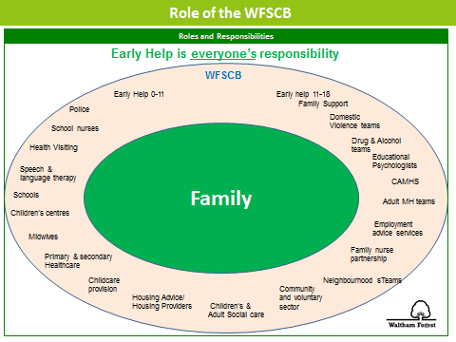

Practitioners can assess further advice and information from the website http://www.walthamforest.gov.uk/earlyhelp where a copy of the Early Help Assessment Form can be found. All the information for Early Help is on The Hub and on the website.

Assessed need is recorded on the actual Early Help Assessment and will be stored centrally by the Early Help Service when submitted to the inbox: EarlyHelp@walthamforest.gov.uk

The Early Help Co-ordinators will assist you with your EHA and convening initial Team around the Family Meetings (TAFs) where a case is complex. In most cases, this will allow for the co-ordination of all appropriate services with an identified Lead Professional for the family.

If you are uncertain who your Early Help Co-ordinator is please send an email to the above address and someone from the team will be in-touch.

It is recognised that for some families to “receive the right help at the right time”, additional support may be needed from the LA’s Early Help service or from Children’s Social Care before an Early Help Assessment has been concluded by using the single request for help and support or protection. The request for Help, Support and Protection form also acts as the first part one of the Early Help Assessment and dovetails with it so that the assessment can be continued by the setting’s practitioner if appropriate, in the future.

There will be varying degrees of consent in some cases i.e. consent to do the EHA but only shared with certain people. Consent should always be discussed with parents and their wishes respected. Communication and engagement with parents is critical to informed consent. It is hoped in the majority of cases parents will see the EHA as something supportive and helpful.

The request for Help, Support and Protection form is available for the website: http://www.walthamforest.gov.uk/earlyhelp
https://www.walthamforest.gov.uk/pages/servicechild/mash-professionals.aspx#ReferralstoMASH

Contact MASH
MULTI AGENCY SAFEGUARDING HUB (MASH) – CONTACT:
Phone: 020 8496 2310 (Monday - Thursday 9am-5.15pm and Fri 9am-5pm)
Mob: Tel: 020 8496 3000 (Out of Hours)
Fax: 020 8496 2313
Email: MASHrequests@walthamforest.gov.uk
Waltham Forest Multi Agency Safeguarding Hub
221 Hoe Street,
Walthamstow
London
E17 9PH
Phone: 020 8496 2310 (Mon-Thurs, 9am-5.15pm and Fri, 9am-5pm)
Mob: 020 8496 3000 (out of hours)
Txt:
Fax: 020 8496 2313
Email: MASHrequests@walthamforest.gov.uk

Allegations regarding person(s) working in or on behalf of the setting (including volunteers)

When an allegation is made against a member of staff, set procedures must be followed. It is rare for a child to make an entirely false or malicious allegation, although misunderstandings and misinterpretations of events do happen.

A child may also make an allegation against an innocent party because they are too afraid to name the real perpetrator. Even so, we must accept that some professionals do pose a serious risk to pupils and we must act on every allegation.

Staff who are the subject of an allegation have the right to have their case dealt with fairly, quickly and consistently and to be kept informed of its progress. Suspension is not the default option and alternatives to suspension will always be considered. In some cases, staff may be suspended where this is deemed to be the best way to ensure that children are protected. In the event of suspension the setting will provide support and a named contact for the member of staff.

The full procedures for dealing with allegations against staff can be found in Keeping Children Safe in Education (DfE, 2015). Staff, parents, owners and trustees are reminded that publication of material that may lead to the identification of a staff member who is the subject of an allegation is prohibited by law. Publication includes verbal conversations or writing, including content placed on social media sites.

Allegations concerning staff who no longer work at the setting, or historical allegations will be reported to the police.
Where an allegation is made against any person working in or on behalf of the setting/establishment that he or she has:
- behaved in a way that has harmed a child or may have harmed a child;
- possibly committed a criminal offence against or related to a child; or
- behaved towards a child or children in a way that indicates he or she would pose a risk of harm if they work regularly or closely with children (refer to the London Child Protection Procedures – Chapter 7: Allegations against staff or volunteers, who work with children)
We will apply the same principles as in the rest of this document, as well as always follow the procedures outlined in the above-mentioned document. This includes allegations against staff in their personal lives.
Whilst we acknowledge such allegations, as all others, may be false, malicious or misplaced, we also acknowledge they may be founded. It is, therefore, essential that all allegations are investigated properly, in line with agreed procedures and outcomes recorded.
Initial Response to an allegation or concern:
Initial Action by person receiving or identifying an allegation or concern
- Treat the matter seriously and keep an open mind
- Make a written record of the information using the Record Form (Appendix 4), including the time, date and place of incident/s, persons present and what was said and sign and date this
- Immediately report the matter to the DSL or deputy in their absence or where the DSL is the subject of the allegation

Initial Action by the Designated Safeguarding Lead/Owner/Manager (The DSL will normally be the Owner/Manager). If the DSL is the subject of the allegation, then the Chair of trustees/Director or the Deputy DSL will take the following action.

- Obtain written details of the concern or allegation but do not investigate or interview child, adult or witnesses
- Contact the LADO within 24 hours or Children’s Social Care after hours service if they cannot be reached
- Discuss with the LADO next steps using the London Child Protection Procedures Flow Charts Allegations/Concerns Against Staff (Appendix 7)
- Inform the Chair of Trustees/Owner of the allegation
- Use the Ofsted online notification system no later than 14 days after the allegation

Subsequent Action by the Designated Safeguarding Lead/Owner/Manager
  - Conduct a disciplinary investigation, if an allegation indicates the need for this
  - Contribute to the child protection process by attending professional strategy meetings
  - Maintain contact with the LADO
  - Ensure clear and comprehensive records regarding the allegation, and action taken and outcome are retained on the staff member’s personnel file
  - Consider along with Human Resources and the LADO whether a referral to the DBS should be made
Children who harm others
Our setting/establishment recognises that the harm caused to children by the harmful and bullying behaviour of other children can be significant.
Children who harm others will pose a risk to other children in the setting/establishment, home and community and risk management strategies will need to be put in place.
Where this harm involves sexual abuse, serious physical or serious emotional abuse, the safeguarding procedures set out in this policy will be applied.
This setting/establishment recognises that children who harm others are likely to have considerable needs themselves and may have experienced or be experiencing significant harm to themselves.
Referrals
Where a child has caused significant harm to another child, through sexual abuse or serious physical or emotional abuse, the setting/establishment will make separate referrals to children’s social care of the victim(s) and perpetrator(s).
Our setting/establishment will be mindful of the sections in the London Child Protection Procedures concerning “Harming Others” and “Sexually Active Children” and work closely with social care, the police and other agencies following the investigation of a referral.
Harmful Sexual Behaviour in EY Settings
If a setting has concerns about a child or young person exhibiting sexualised or harmful sexual behaviour they should consider a referral to the MASH and should compile a chronology of relevant incidents to support pattern mapping. This will then inform the plan both for the child that has harmed and the child that has been harmed. Throughout the process it is desirable that parents are engaged and informed.
Referrals
Where a child has caused significant harm to another child, through sexual abuse or serious physical or emotional abuse, the setting will make separate referrals to children’s social care of the victim(s) and perpetrator(s).
Our setting will be mindful of the sections in the London Child Protection Procedures concerning “Harming Others” and “Sexually Active Children” and work closely with social care, the police and other agencies following the investigation of a referral.

Appendix 1

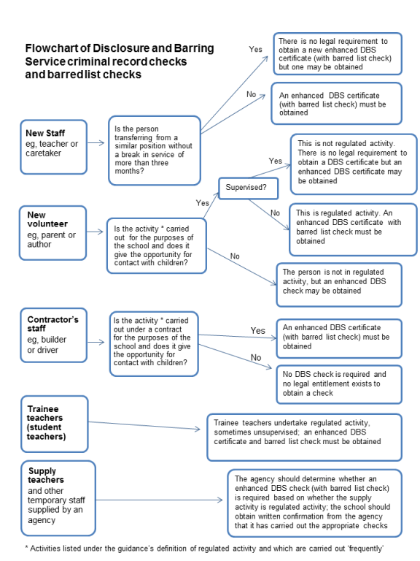

Appendix 2

Key contacts for child protection issues in Waltham Forest
The following details relate to key personnel in Child Protection who can be contacted should any child protection issues arise.
Name |  | Agency |  | Contact details
Designated Doctor for Child Protection |  | North East London Foundation Trust (NELFT) |  | 020 8430 7893  07795 548987
Named Nurse for Safeguarding – Community Health Services, School Nursing, Health Visitors and Child & Adolescent Mental Health Services (CAHMS) |  | North East London Foundation Trust (NELFT) |  | 020 8430 7827/7822  07568 130143  Fax: 020 8430 7981
Named Nurse for Safeguarding |  | Barts Health at Whipps Cross University Hospital Paediatric A&E |  | 020 8535 6855 bleep 514  Pager: 08700555500 ask for 850122  Secretary: Ext 5072
Police Referral Desk |  | Metropolitan Police Child Abuse & Investigation Team (CAIT) |  | 020 8345 3633  020 8345 3693
Designated Nurse for Safeguarding Children – GP Services |  | Clinical Commissioning Group (CCG) |  | 020 3688 2638
Divisional Director for Children & Families Services |  | Waltham Forest Children & Families Services |  | 020 8496 3206
Head of Service – Quality Assurance (QA)Service |  | Waltham Forest Children & Families Services |  | 020 8496 3685
Deputy Head of Service – Quality Assurance (QA) Service |  | Waltham Forest Children & Families Services |  | 020 8496 3250
Duty Child Protection Co-ordinators – Quality Assurance (QA) Service |  | Waltham Forest Children & Families Services |  | 020 8496 8279
Local Authority Designated Officer (LADO) – Quality Assurance (QA) Service |  | Waltham Forest Children & Families Services |  | 020 8496 3646
Safeguarding in Education Service |  | Waltham Forest Children & Families Services |  | 020 8496 6310  020 8496 8277
Head of Service – Children’s Safeguarding & Family Support Service |  | Waltham Forest Children & Families Services |  | 020 8496 8393
Deputy Heads of Service – Children’s Safeguarding & Family Support Service |  | Waltham Forest Children & Families Services |  | 020 8496 1375  020 8496 2338
Team Manager – Waltham Forest Multi Agency Safeguarding Hub (MASH) Team/Children’s Referral & Advice Team |  | Waltham Forest Children & Families Services |  | 020 8496 2317
Waltham Forest Multi Agency Safeguarding Hub (MASH) Team/Children’s Referral & Advice Team |  | Waltham Forest Children & Families Services |  | cscreferrals@walthamforest.gov.uk020020 8496 2313 (Fax)  020 8496 2307/10/11/16/17
Team Manager – Children’s Emergency Duty Team (Out of Hours) |  | Waltham Forest Children & Families Services |  | 020 8496 3000

Appendix 3

SAFEGUARDING CHILDREN: WHISTLE BLOWING
A MODEL POLICY FOR LONDON BOROUGH of WALTHAM FOREST SETTING/ESTABLISHMENTS
This guidance is written for staff¹ working with children and young people in education settings including PVI settings/establishments.
Staff must acknowledge their individual responsibility to bring matters of concern to the attention of senior management and/or relevant agencies. Although this can be difficult this is particularly important where the welfare of children may be at risk.
You may be the first to recognise that something is wrong but may not feel able to express your concerns out of a feeling that this would be disloyal to colleagues or you may fear harassment or victimisation. These feelings, however natural, must never result in a child or young person continuing to be unnecessarily at risk. Remember it is often the most vulnerable children or young person who is targeted. These children need someone like you to safeguard their welfare.
Don't think what if I'm wrong - think what if I’m right

Reasons for whistle blowing
- • Each individual has a responsibility for raising concerns about unacceptable practice or behaviour
- • To prevent the problem worsening or widening
- • To protect or reduce risks to others
- • To prevent becoming implicated yourself

What stops people from whistle blowing
- • Fear of starting a chain of events which spirals out of control
- • Disrupting the work or project
- • Fear of getting it wrong
- • Fear of repercussions or damaging careers
- • Fear of not being believed

How to raise a concern
- You should voice your concerns, suspicions or uneasiness as soon as you feel you can. The earlier a concern is expressed the easier and sooner action can be taken
- Try to pinpoint exactly what practice is concerning you and why
- Approach your immediate manager, Designated safeguarding lead for Child Protection, or Owner/manager or LA for guidance
- If your concern is about your immediate manager/Owner, speak to the Chair of Governors/chair of committee or if you feel you need to take it to someone outside the setting, contact the Safeguarding Team
- Make sure you get a satisfactory response - don't let matters rest
- Ideally, you should put your concerns in writing, outlining the background and history, giving names, dates and places wherever you can

A member of staff is not expected to prove the truth of an allegation but will need to demonstrate sufficient grounds for the concern.
¹Staff includes any adult, paid or voluntary, who works in a setting/establishment.

What happens next
- • You should be given information on the nature and progress of any enquiries
- • Your employer has a responsibility to protect you from harassment or victimisation.
- • No action will be taken against you if the concern proves to be unfounded and was raised in good faith
- • Malicious allegations may be considered as a disciplinary offence

Self reporting
There may be occasions where a member of staff has a personal difficulty, perhaps a physical or mental health problem, which they know to be impinging on their professional competence. Staff have a responsibility to discuss such a situation with their line manager so professional and personal support can be offered to the member of staff concerned. Whilst such reporting will remain confidential in most instances, this cannot be guaranteed where personal difficulties raise concerns about the welfare or safety of children.

Further advice and support
It is recognised that whistle blowing can be difficult and stressful. Advice and support is available from your line manager, HR department and/or your professional or trade union.
"Absolutely without fail- challenge poor practice or performance. If you ignore or collude with poor practice it makes it harder to sound the alarm when things go wrong" (reproduced with acknowledgement to “Sounding the Alarm” – Barnardos)

Safeguarding in Education Service
Tel: 0208 496 3000

With acknowledgement to Surrey Children’s Services for their Model Policy on ‘Whistle Blowing’.

Appendix 4

RECORD FORM Date: ________

Safety and Welfare Concern Form (to be written ASAP after not during your conversation with the child)

Child’s Name: | Class: | DOB: | Gender:

Date: | Time: | Place: | Name of person completing this form (please print):

Nature of Concern/Conversation (continue on a separate sheet if necessary)

Describe any marks you may have seen – noting size and position (refer to body map)

Name of person you reported your concerns to

Action to be taken / recommendations from the designated member of staff
Signed: Position:

Return the completed form to the Designated Safeguarding Lead ASAP

Appendix 5

Appendix 6
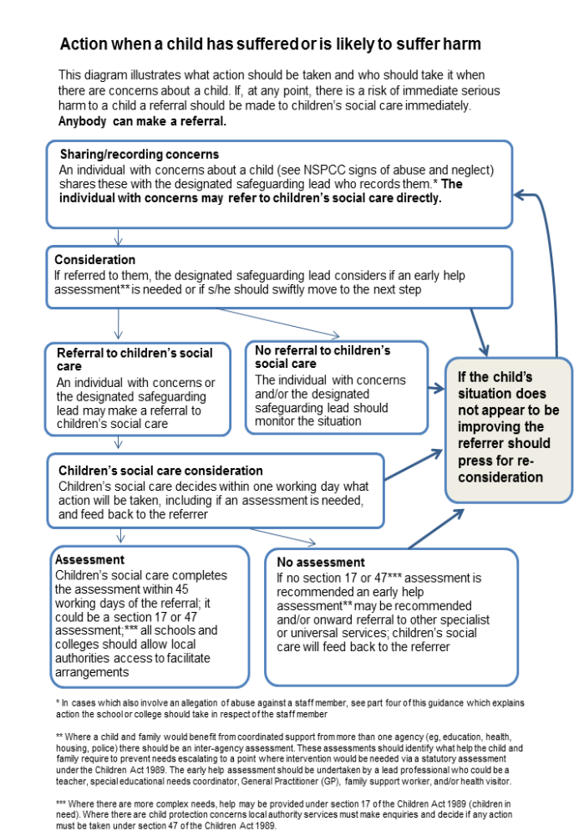

Appendix 6

BUSINESS MANAGER: Suzanne Elwick
Tel: 020 8496 3683
suzanne.elwick@walthamforest.gov.uk
www.walthamforest.gov.uk/lscb

June 2015
Dear Colleague,

Re: How to escalate professional concerns about a child

I would like to advise you and staff in your organisation who have a child protection responsibility how to take action using the appropriate channels when you believe that your professional opinions have not been acted on appropriately. Please disseminate this advice widely to appropriate staff.

For example, if you have concerns regarding the lack of response to professional opinions and judgements expressed by your staff about safeguarding matters including concerns that social care services are not taking appropriate actions regarding the well-being of a child, or are not responding in a timely fashion to your concerns.

In the first instance please raise any concerns directly with the manager of the allocated social worker. If there is no allocated social worker please speak to the manager of referral and advice as below:

Children Social Care and Education

Team Manager MASH/Referral and Advice | 020 8496 2317

If you feel your concerns have still not been acted on appropriately then please escalate your concerns to the relevant head of service:

Head of Safeguarding and Family Support | 020 8496 1907
Deputy Head of Safeguarding and Family Support | 020 8496 1375
Head of Children in Care | 020 8496 8388
Deputy Head of Children in Care | 020 8496 2184
Head of Placement and Resources | 020 8496 2136
Deputy Head of Placement and Resources | 020 8496 2478
Head of Quality Assurance | 020 8496 3685
Deputy Head of Quality Assurance | 020 8496 8250

Where you remain concerned following your discussion with the head of service, a senior member of staff in your organisation should then speak to:

Divisional Director of Children and Families | 020 8496 3206

If you remain concerned, the most senior manager in your organisation should speak to the Deputy Chief Executive, Families Directorate:

Deputy Chief Executive, Families Directorate | 020 8496 3501

In the event that your concerns involve children social care in another local authority area, the above staff will contact the relevant staff in that organisation.

It is important that concerns are speedily escalated within the management structure for children’s social care until a satisfactory resolution of the concern is secured.

If you have any concerns related to the safeguarding practice of any other agencies, in the first instance please speak to the team manager of the practitioner, and if you remain concerned please contact the following. If you do not receive a satisfactory response please ask for the next appropriate manager to speak to.

Schools

Divisional Director Educational Improvement | 020 8496 3221

Barts Health at Whipps Cross Hospital

Named Nurse for Safeguarding | 020 8535 6855

Police

Detective Inspector, Sexual Offences, Exploitation and Child Abuse Command or next stage Detective Chief Inspector | 020 8217 6411/6471

Community health services, school nursing, health visitors, child and adolescent mental health services

Named Nurse for Safeguarding, NELFT | 020 8430 7827  M: 07738 803104

Community health Child Protection Doctor

Designated Doctor for Child Protection, NELFT | 0208 430 7883  M:07795 548987

Waltham Forest Clinical Commissioning Group (WFCCG)

Designated Nurse for Safeguarding, WFCCG | 020 3688 2681  M:07538798129
Designated Nurse for Looked After Children, WFCCG | 020 3688 2670  M:07930195306

If you have any general enquiries about the contents of this letter, please contact Suzanne Elwick, Waltham Forest Safeguarding Children Board, Business Manager, 020 8496 3683, suzanne.elwick@walthamforest.gov.uk.

Please bring this letter to the attention of all staff.

Yours sincerely

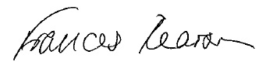
Fran Pearson WFSCB Independent Chair

Appendix 7
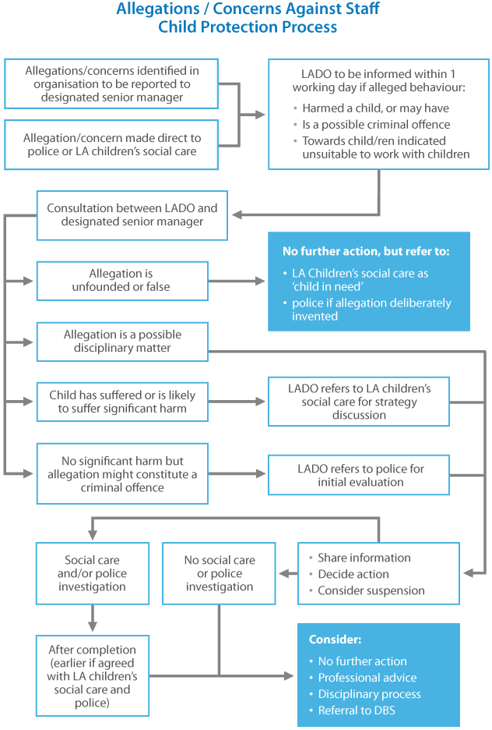
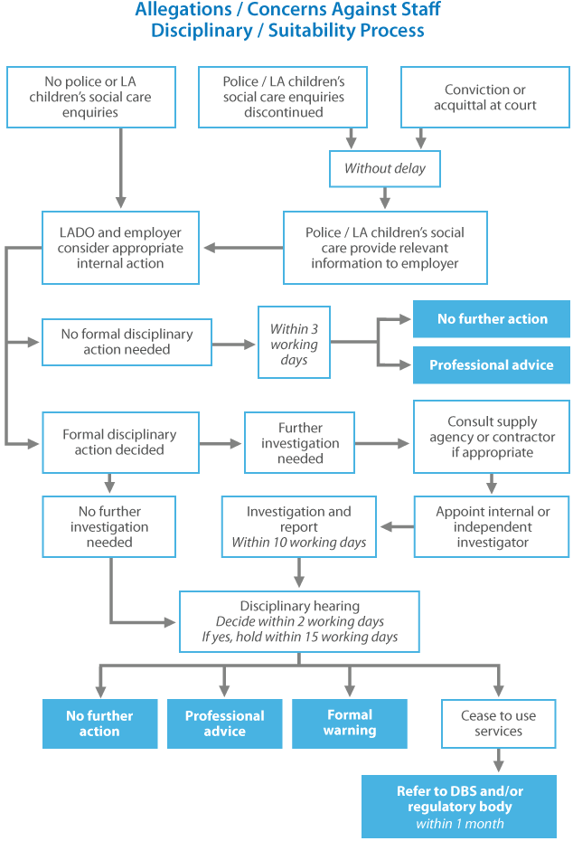

This website has been designed and is powered by tri.x and is the copyright of the London Safeguarding Children Board

Appendix 8

Request for Help and Support or Protection


Guidance

If you do not have direct access to Waltham Forest Families Information system then this form should be completed and emailed, to the MASH team:

Tel: 0208 496 2310 | Email: MASHrequests@walthamforest.gov.uk

(for NHS.net accounts please can you send to MASHrequests@walthamforest.gov.uk.cjsm.net )

Requests for Help and Support and or Protection must be made via this form and all relevant sections MUST be completed in order to support a good referral. For guidance please refer to the Threshold Document http://www.walthamforest.gov.uk/pages/servicechild/mash-profession- als.aspx

You can make a ‘Request for Help and Support’ if you think a child or family has additional needs which require a multi-agency intervention, for example, persistent truanting, chronic/ recurring health problems, or behaviour is harmful to self and others. Before making this request you should gain consent of the child/young person or family concerned.

However, if you are worried that a child is at risk of significant harm i.e. through abuse or neglect you should make a ‘Request for Protection’. In this case you should inform the parents unless this will endanger the child’s safety.

FEED BACK TO REFERRERS

- We will ensure that your referral reaches the correct team and that you receive a written response to your referral within 48 hours of receipt of a fully completed form (24 hours if there are Protection concerns). This is automatically generated by the Families Information System.

- If you do not hear back from us regarding the outcome and/or progress of your referral, please contact the MASH Administrator on 020 8496 2310 who will inform you of your referral.

- If you encounter any difficulties in relation to your referral that you wish to bring to the attention of a Senior Manager, please contact the Head of Service for Safeguarding and Family Support on 0208 496 2310

Contact Details

Details of person making contact
Name:
Agency / Team:
Role / Job title:
Address
Contact Number(s):
Date of this request:

Consent / Information sharing:
Note: Consent must always be sought unless it puts a child at further risk to do so.

Has the parent or child / young person consented to the requested being made | Yes |  | No

The child / young person knows about the referral: | Yes |  | No
If no, please state the reason(s):

The parent / carer knows why the referral is being made: | Yes |  | No
If no, please state the reason(s):

The parent / carer understands and agrees to agencies sharing information: |  | Yes |  | No
If no, please state the reason(s):
Request Type
Please state what your primary request is for:
Request for help and support (Complete section A & B)
Request for protection (Complete section A & C)
Section A - Information about the child/ren and family

Parents/carers details of subject child / young person:

 | Mother |  | Father
Full name of parent:
Address of parent:
occupation:
Address:
Contact Number(s):
Add details of all subject(s)  Child/ren Young Person |  | - UPN - Unique Pupil Number  - Other Name(s) – Aliases/ Also Known As/ Previous Name(s)  - DOB – Date of Birth  - EDD – Expected Date of Delivery  - EHC – Education, Health & Care plan  Note: A statement of special Educational Needs, has been replaced by an EHC plan as of 1st Sep 2014

NHS ID | UPN ID | First name | Surname | DOB / EDD | Age | Gender | Address | Ethnicity | Religion | Has EHC plan

Does the child/children have any known disabilities

Details of family / household members:

First Name | Surname | DOB / EDD | Age | Gender | Address | Relationship with subject(s) | Parental Responsibility | Ethnicity | Religion

Details of other significant people not living in the household:

First Name | Surname | DOB / EDD | Age | Gender | Address | Relationship with subject(s) | Parental Responsibility | Ethnicity | Religion

Communication needs (including language) regarding any of the people named above

Legal status / Immigration status regarding any of the people names above:

Presenting issues
Please select all presenting issues that apply

Child / Young Person:
Abuse / Neglect Emotional Abuse |  | Abuse/ Neglect – Neglect |  | Abuse / Neglect – Physical Abuse
Abuse / Neglect Sexual Abuse |  | Alcohol Misuse |  | Anti-social Behaviour
Beyond Parental Control |  | Challenging Behaviour |  | Emotional Neglect
Child Missing Education |  | Domestic Abuse |  | Drugs Misuse
Elective Home Education |  | Female Genital Mutilation |  | Intentionally homeless
Gangs |  | Honour Based Violence |  | Forced marriage
Learning Disability |  | Mental Health |  | Missing from Education
Missing from Home |  | No Recourse to Public Funds |  | Physical Disability or illness
Privately Fostered |  | Protection / At Risk |  | Self-Harm
Sexual Harmful Behaviour |  | Sexual Exploitation |  | Socially Unacceptable Behaviour
Trafficking |  | Unaccompanied Asylum Seeking Children |  | Under 16 Year Old Pregnancy
Violent Extremism/Radicalisation |  | Young Carer |  | Child / Young Person In Need
School Attendance

Parent / Carer
Alcohol Misuse |  | Domestic Abuse |  | Drug Misuse
Intentionally Homeless |  | Learning Disability
No Recourse to Public Funds |  | Physical Disability or illness

General:
Alcohol Misuse |  | Domestic Abuse |  | Drug Misuse
Family Breakdown |  | Family Dispute |  | Financial Support
Learning Disability |  | Mental Health |  | Physical Disability or illness

Key agencies involved:
Add name, agency and contact details of all professional involved.
Name |  | Address
Role |  | Contact number(s)
Agency |  | Email address

Details of lead professional:

Name:
Agency / Team
Role / Job title
Address
Contact Number(s):
E-mail Address

The purpose of this section is to assist the inter-agency assessment. Where you do not know on this area please record ‘Not Known.’ (NK) Record the strengths as well as areas of need or risk so that resources can be directed appropriately.

Information supporting this referral:

Child/Young Person’s developmental needs/risk factors

 | Y | N | N/K | Y | N | N/K
 | NEED/RISK |  |  | STRENGTHS
Health
Emotional
Behavioural Development
Education
Identity
Family
Social Relationships
Social Presentation
Self-care

Parents/carers capacity to respond to child / young person:

 | Y | N | N/K | Y | N | N/K
 | NEED/RISK |  |  | STRENGTHS
Basic Care
Ensuring safety
Emotional Warmth
Stimulation
Provision of guidance
Boundaries
Stability

Please add any additional details here:
Section B – Request for Help and Support

What led to this referral:
What support has been provided to date to the child / young person or family:
Has this supported any positive changes for the child / young person:
What further support do you think is needed:
What are the outcomes you would like to see as a result:

Has an Early Help Assessment been completed:
Yes |  | No |  | If Yes, please attach the Early Help Assessment to this referral.
Have you discussed this case with a WF Early help Co-ordinator? |  |  |  |  | Yes |  | No
Who else has provided information to inform this request

Please attach or send any other assessments that have been completed.

Section C – Request for Protection

Please state why you think the child / young person has met the threshold for a social care assessment:
Section D – Information to referrer ( to be completed by Local Authority)

Once you have submitted this form the information will be collated and our Multi Agency Team will make a decision about the next step. This decision will be made within 48 hours of receipt of a fully completed form (24 hours if there are Protection concerns) and you will be notified accordingly.

Response to referrer form completed: |  |  |  |  |  |  |  | Date sent to referrer
Yes |  |  | No
Completed
Outcomes
Early Help Services |  |  |  |  |  |  | Children’s Social Care
Contact Name
Contact Number(s):

Thank you for your request for Help and Support or Protection

“teacher” means— (a) in relation to England, a person within section 141A(1) of the Education Act 2002 (persons employed or engaged to carry out teaching work at schools and other institutions in England); (b)in relation to Wales, a person who falls within a category listed in the table in paragraph 1 of Schedule 2 to the Education (Wales) Act 2014 (anaw 5) (categories of registration for purposes of Part 2 of that Act) or any other person employed or engaged as a teacher at a school (within the meaning of the Education Act 1996) in Wales.

